**Flexpoint 0.5mm Pitch Break Out Evaluation**

**Nikhil Jali**

* The break-out connector received has the following mating dimensions:

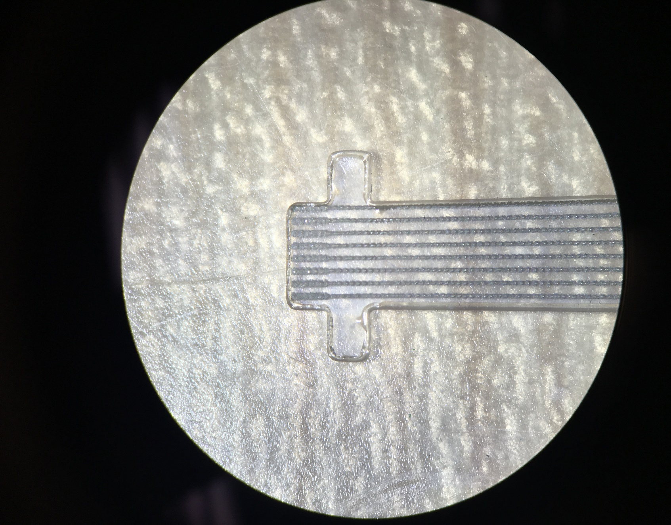

**4.30mm**

**1.80mm**

**1.80mm**

**2.00mm**

**8 Channels**

**Thickness: 0.3mm**

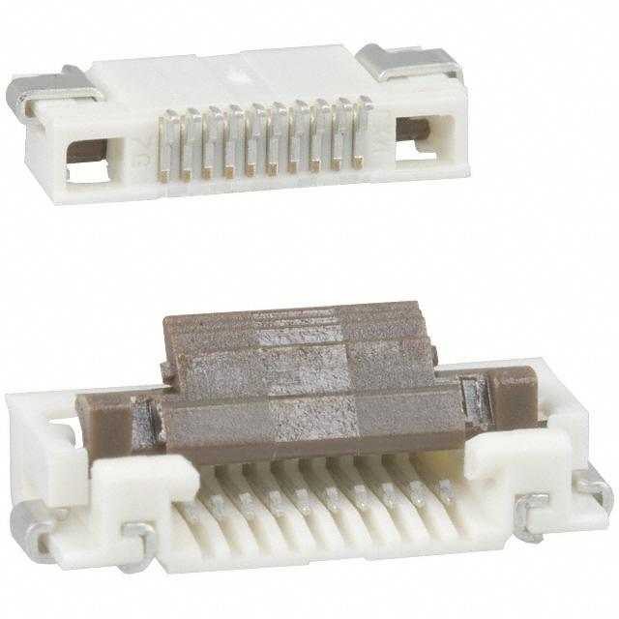The following 10-pin connector is being used: WM9203CT-ND [[Digikey Link](https://www.digikey.com/product-detail/en/molex-llc/0528921095/WM9203CT-ND/1089660)]

* **Pin Number Mismatch**: Since the breakout has 8pins and the connector 10, there is a mismatch of width between the breakout and connector, thus allowing for play between the two. This play is wide enough to have the terminals of the breakout connect to adjacent terminals in the connector.

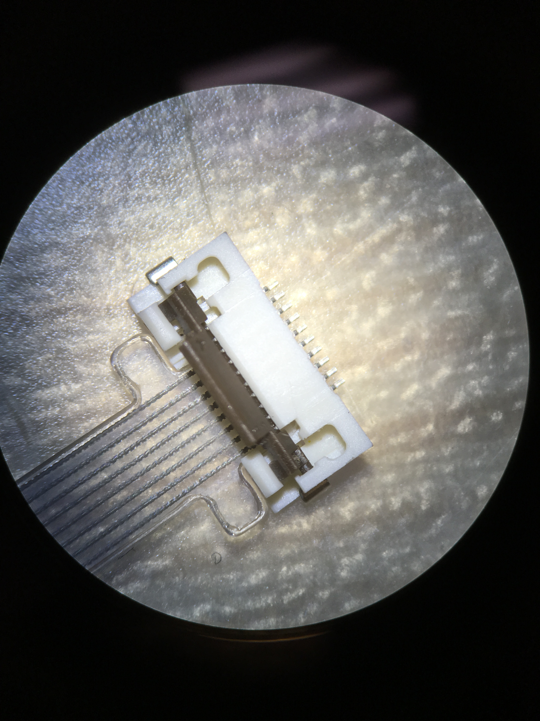

**Play**

* 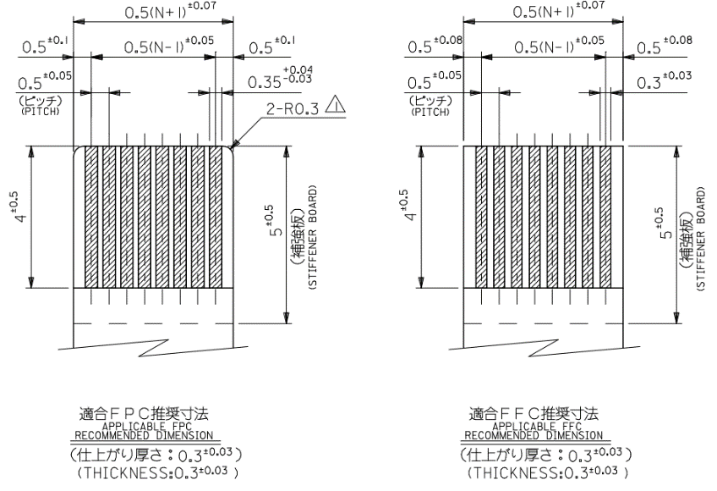**Insufficient Insertion Length:** The 1.80mm of insertion length is insufficient to reach the connector’s terminals. The connector datasheet[[weblink](http://www.molex.com/pdm_docs/sd/528921095_sd.pdf)] describes a 4mm length (page 2).

**1.80mm**

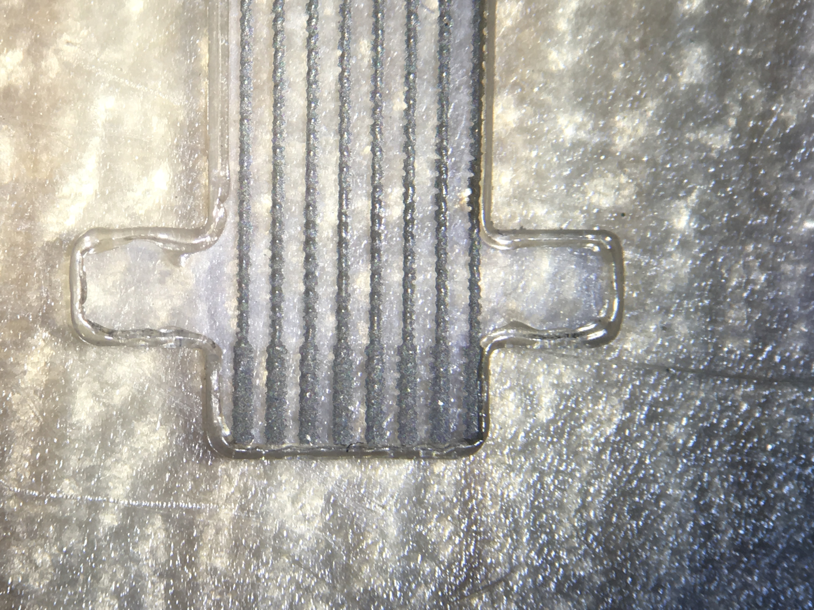

* **Track Severage due to Connector:** A major risk and failure point was identified between the interface of the connector and the FPC breakout. The terminal pins of the connector were found to have sharp edges that cut into the breakout thereby severing the tracks within two uses. The pin and the severed breakout are shown below:

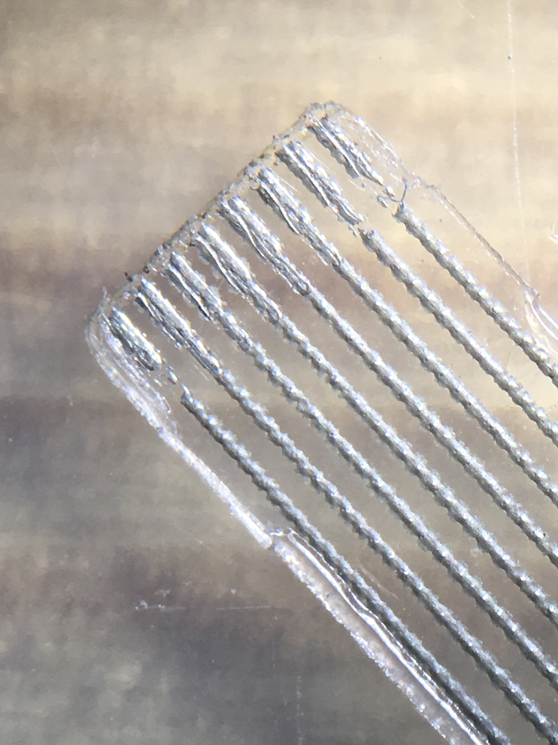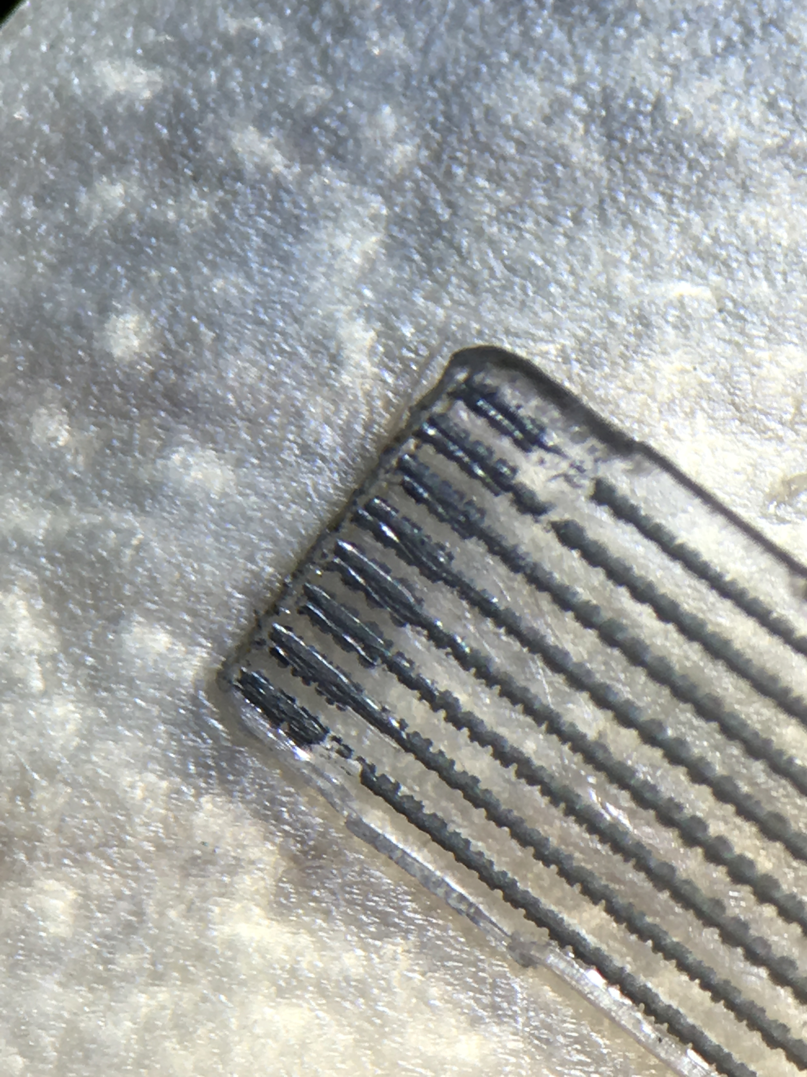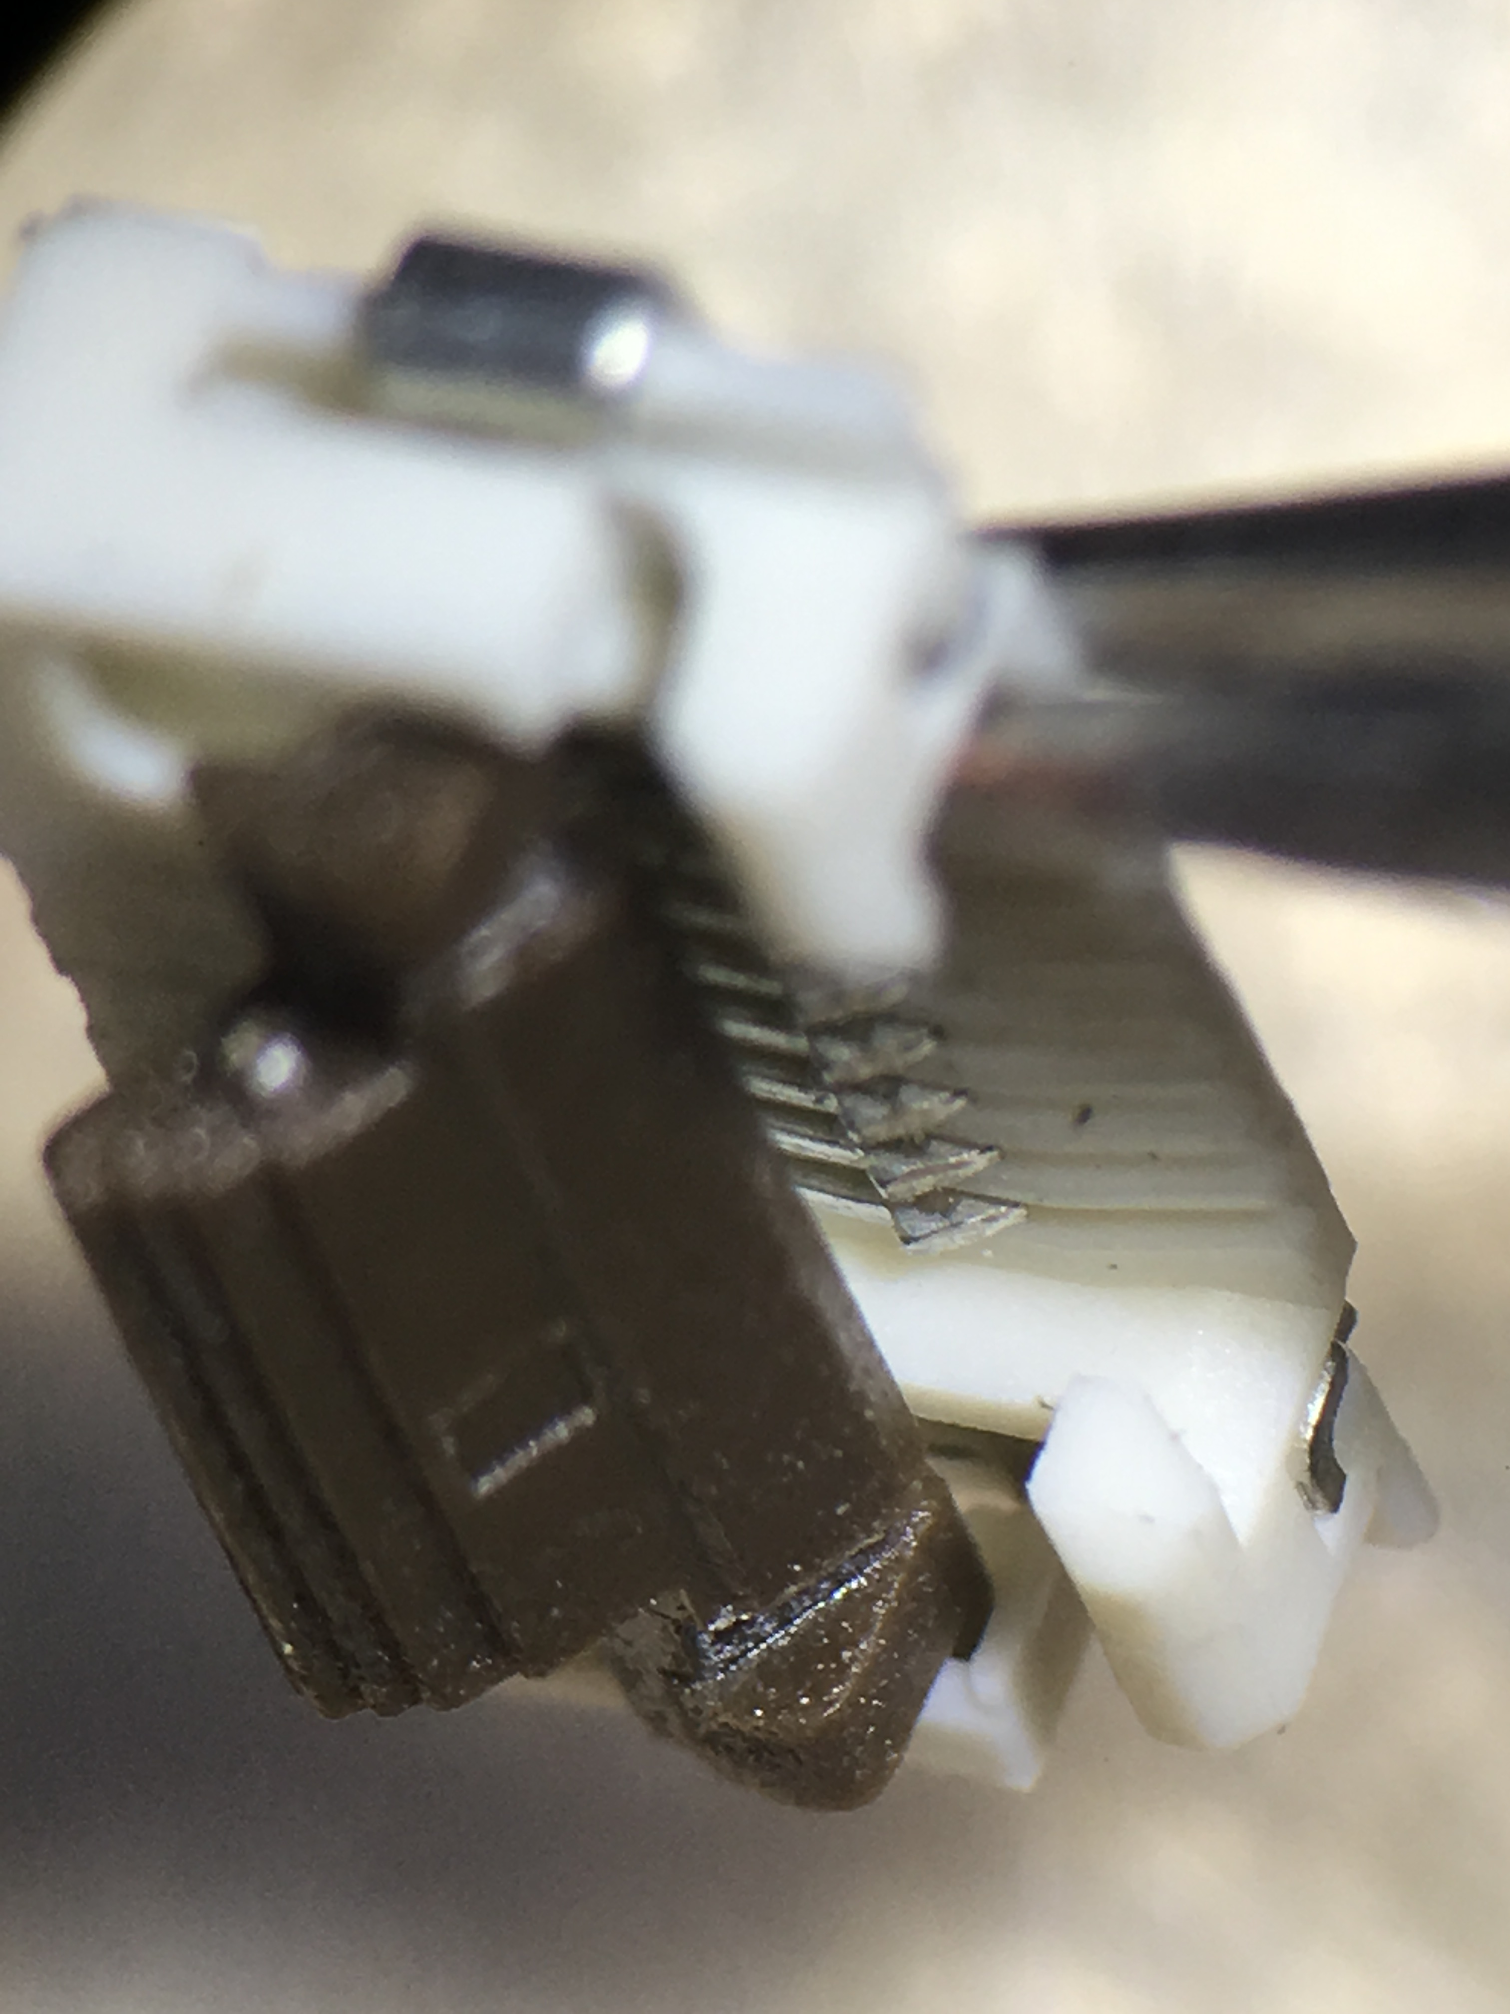

**Sharp Edges on Connector Terminals**

**Severed   
Tracks**

**SUMMARY: Connector unsuitable for use with FPC Sensor**